Example 1,2 are generated by “Straight_Skeleton_2”, According to their algorithm, they consider that, if two input collinear edges are not one edge, and their angular bisector (Bic) is perpendicular to this line.
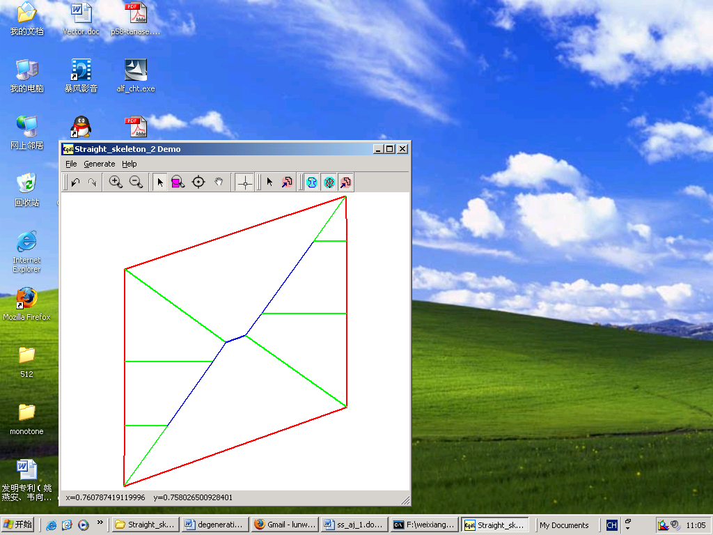

Example 1

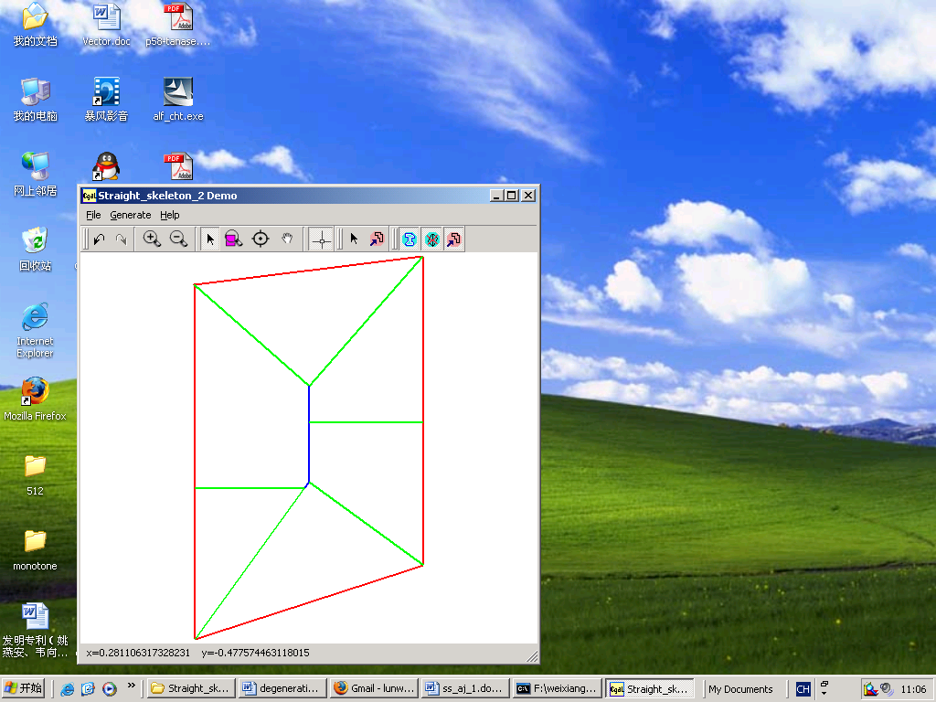
Example 2

