In the following example, we will discuss such a case that one of the edges of the reflex vertex is parallel to the split edge, and the other edge of it is on the same line with the successor edge of the split edge. This is important to my current work, regardless my opinion is correct or not, I have formed my own Divided-and-Conquer Algorithm for S(P) generation.
For example,
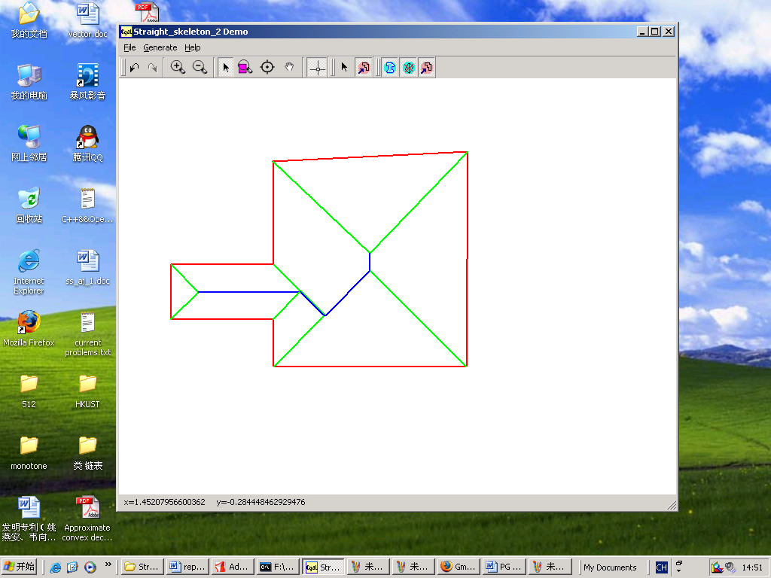
(a) S(P) generated by the software of “Straight_Skeleton_2”
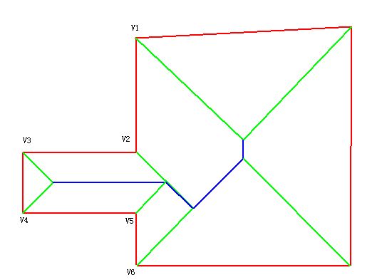
(b) V2 “split” V4V5, V1V2 is on the same line with V5V6
Fig.1
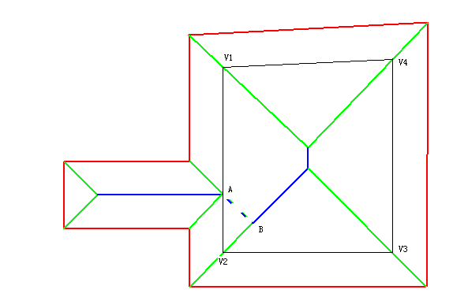
Fig.2 The current P(V1V2V3V4) at the event A

In my opinion, in Fig.2, S(P) piece AB COULD NOT exist in reality! In this sense, the S(P) pieces of original P can be separate.
The correct S(P) of this P is shown in Fig.3.
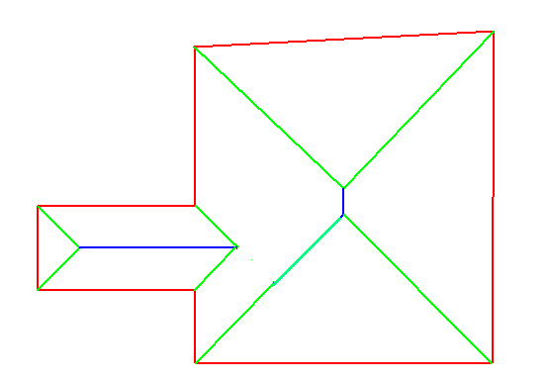
Fig.3
See also the following examples:
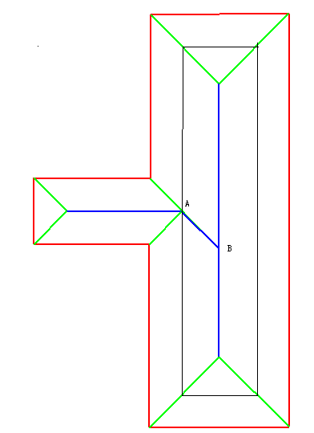
Fig.4 AB should be abandoned.

